Theme 4: Staying safe at home – Parent’s conversation
Before you start - Remember:
- Remind yourself of the Safeguarding Code of Conduct
- Check with the parent that this is a good time for the call
- Remember to ask both the child and parent if they are still happy to take part in the project
- Take notes so that you are able to complete the call log accurately after the call

Beginning the time together
- Ask about what have been the best parts and most difficult parts of the last week
- Follow up on last week’s commitment: Did they manage to put it into practice?
- Reminder of the process: What to expect from these calls and how long they will last

Introduce the theme: Staying safe at home
Today’s topic is staying safe at home - by the end of our call we will have talked about:
- When we get angry
- How to use positive discipline with our children

Topic 1: When I get angry
Ask: What has been a time this week that you remember feeling angry about something or with someone at home? What did you do when you felt angry? (Be prepared to share your own experience)
Affirm: Under stress it is normal to feel more angry than usual – whether about big things or small! We love our children and teenagers, but the stresses of COVID-19, money and lockdown can make us angry. Our anger doesn’t need to be out of our control – we can do things before and during it to help us manage it.
Ask: The same things usually make us get stressed and angry every time – can you see any patterns in what makes you angry and how do you normally react? Do you know what helps you to respond well?
Share: There are ways we can help ourselves prevent anger from starting - for example:
- If we usually get angry when we are tired, can we get more rest?
- If we are angry when we are hungry, can we make sure we eat? (be sensitive to families who may not have enough food)
- If we are angry when we feel alone, can we ask for support or make sure we connect with others?
- If we feel under pressure and overwhelmed, can we make sure we are doing something that we enjoy and taking some time for ourselves somehow?
Ask: Can you think of any ways you could prevent your anger from starting?
Affirm: That sounds great! But also, however much we prepare, we will all still feel angry sometimes! We can also be prepared to react to our anger in a positive way.
Share: Taking a break is one of the best ways to manage anger:
- When you start feeling angry, take a 20-second cool down. Breathe in and out five times before you speak or move.
- Go somewhere else for 10 minutes to regain control of your emotions. If you have safe outdoor space, go outside.
- [if relevant in your context:] Drinking alcohol can influence our reaction. Cut back on drinking or don’t drink, especially when children are awake.
- Do you have weapons or things that can be used to hit others? Lock them up, hide them, or take them out of the home.
Ask: Is there something we’ve talked about that you want to try to put into practice this week?
Topic 2: Using positive discipline with our children
Ask: What have you noticed about children’s behaviour during this time? Is it the same as usual or have you noticed more difficult behaviour?
Affirm: All children misbehave. It is normal when children are tired, hungry, afraid, or learning independence. And this can be extra hard to cope with when we are all at home together for a long time!
Ask: How confident are you in using positive discipline rather than physical discipline with your children? (Uses positive discipline: all of the time/most of the time/some of the time/none of the time)
Ask: What are some of the ways you help to encourage positive behaviours in your children?
Share: Some ideas for positive discipline:
- Encourage positive behaviour by using positive words to say the behaviour you want to see (e.g. ‘Please put your books away’ rather than ‘Don’t make a mess’) and praise your child when they are behaving well.
- Redirect unwanted behaviour quickly when you notice it beginning, by suggesting another activity.
- Use consequences rather than hitting or shouting – this is more effective and teaches children responsibility. Giving your child a chance to follow instructions before giving them the consequence. Stay calm when giving the consequence and make sure it is something you can follow through with. Consequences should be proportionate and reasonable.

Ask: What will you do differently for one specific behaviour with one specific child this week?

Share: Sometimes something happens at home or outside that makes a child feel unsafe – abuse or violence against children is one of the things that can make them change their behaviour and seem to be behaving “badly”. If we notice changes in our child’s behaviour or see any physical signs of violence we should encourage the child to talk to us.
Share: Share the appropriate procedure for reporting child abuse in your context (e.g. child helpline, social services, NGO or police)
Putting it into practice this week
Could you try to talk with your child together about what ideas you and they have for how you can both manage your anger effectively? What could you do if you notice each other getting angry? Try out the ‘I can calm myself down’ activity together (sent via WhatsApp or explained during the call).
Explain: The game and poster you will send over WhatsApp or in print – if possible
Confirm: What do they plan to put into practice with their child this week?
[Action to prevent anger / Action to manage anger / Try not to use physical violence at home / Different method of positive discipline / Other]
When will you meet again?

Ask: the parent if they are happy for you to speak to the child now and ask them to hand over the phone.

Theme 4: Staying safe at home – Child’s conversation
Before you start - Remember:
- Remind yourself of the safeguarding code of conduct
- Remember to ask the child if they are still happy to take part
- Take notes so that you are able to complete the call log accurately after the call

Beginning the time together
- Begin with your regular check-in questions, such as:
  - What was the best thing that happened this week?
  - What was something funny that happened this week?
  - What was hard about this week?
- Reminder that these calls are about: checking on how you are doing, giving you a chance to talk and share how you are feeling, and sharing ideas together which can help you and your family
- Ask: Are you still happy to be part of this project?

Introduce the theme: Staying safe at home
Explain: Ask the child to tell you something they can do with the part of their body you name. You can take it in turns to ask one another, choosing a different part of the body each time.
E.g. “Legs” – “Running fast!” “Eyes” – “Noticing when my sister is sad”
What’s something you’re glad you can do with your…

- Ears?
- Feet?
- Mouth?
- Hands?
- Legs?
- Eyes?

Explain that today we’ll be looking at how we can stay safe at home, including how we use our bodies in a positive way.

Topic 1: Me and my body
Ask: It’s great that we can use our body to do so many good things as we just talked about. But sometimes we can also use our bodies in less helpful ways - maybe to hurt others or even ourselves. Can you think of any examples of this?
Some examples might be:

- Using our hands to hit or hurt each other
- Using our feet to kick someone
- Using our mouth to say unkind words

Share: All of us get angry and upset sometimes (both children and adults!) and especially at the moment when things are hard and confusing, sometimes we can find it hard to stay calm and kind.
Ask: Can you think of a time you felt angry this week? What happened? What did you do? (Be ready to share your own example with the child, to show that all of us can find life difficult!)
Ask: What do you normally do when you feel angry? Does this help you feel better?
Share: Some things we can do if we feel angry:

- Count to ten
- Walk away from the situation
- Breathe slowly and deeply
- Talk to someone you trust
- Do some exercise or physical activity
- Write or draw how you are feeling

Ask: Will you try something different this week when you feel angry?

Topic 2: Someone I can talk to
Ask: What would you do if something happened to make you feel unsafe tomorrow?
Do not prompt the child for answers, but record if they give any of the following answers:
[Talk to someone I trust/ Tell someone to stop what they are doing/ Get away from the situation/ Don’t know]
Ask: Look at your hand and your five fingers. It’s important that we have people to talk to in case we’re feeling scared, upset, angry or sad. Can you think of five people you can talk to if you are having a hard time? (one for each finger) (This might include parents, siblings, friends, wider family, teachers, mentors, faith leaders or others).
Affirm and ask: Can you still talk to these people at the moment? If not, is there someone else at home you can talk to?
Share: One of the other ways we can hurt one another is by touching someone in a way that makes them feel uncomfortable or when they do not want it. If that happens to us, we should know that we can:

- Tell this person to stop
- Get away from the situation
- Tell someone we trust about it

We should never keep secrets that make us sad or worried, and so it’s important to think ahead about who are the people that we will talk to if we ever feel worried. We should always tell someone if we feel worried about something or feel like something is making us uncomfortable.
Remind the child that while this programme is going on, you are also happy to listen to any worries they have, though it’s great if they can find someone who is always there, like a parent or sibling, or teacher.

Wrap up: What can we do together this week?
Ask: What is one thing you will do this week to help you if you feel angry, or to talk to someone you trust?
[Do something different if I feel angry / talk to parent about managing anger / talk to someone I trust if I am worried / other]
Close the call by thanking the child for talking with you, and explain when you will meet again.
After the call
- Share the poster or image over WhatsApp or as a printout if you are able to: ‘When We Get Angry’
- Share the activity over WhatsApp or as a printout if you are able to: ‘I can calm myself down’
- Complete the call log now
- Contact your supervisor if any safeguarding issues have been raised or if you have any concerns

NB – images to share (your programme supervisor will share these with you)
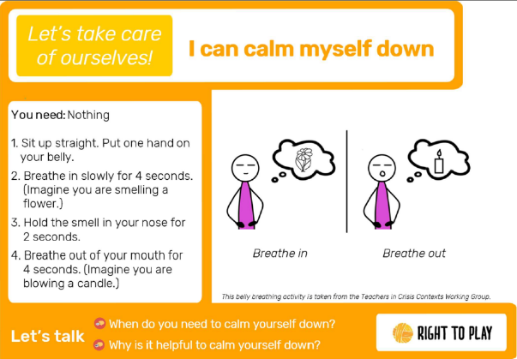
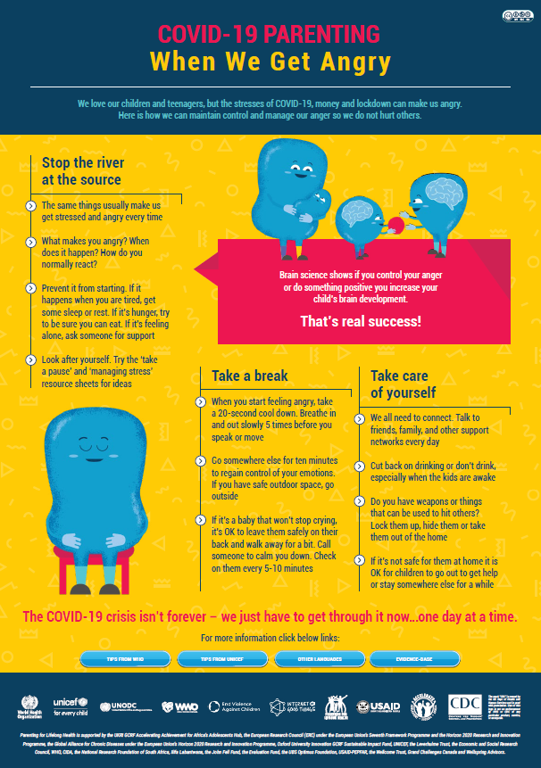
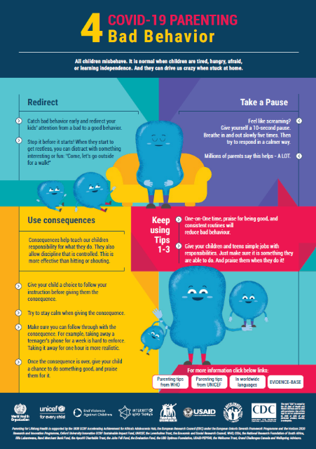
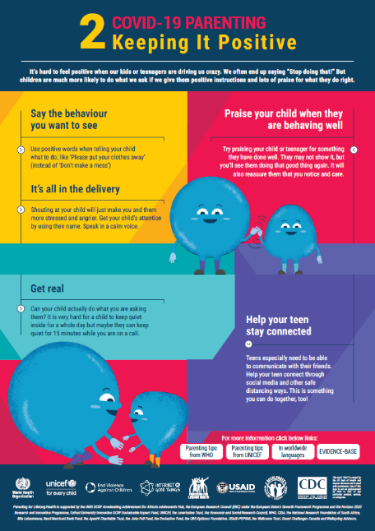
If ‘when we get angry’ is not available in your language, you may choose to use ‘bad behaviour’ or ‘Keeping it positive’ which also contain some points from this week’s conversation. You may also choose to send these additionally.

